OudhTrade
Database Design
Module 1 — Platform Foundation · M01-5
Document details
Company | MRIDA INFRA AND PLANTATIONS LLP
Product | OudhTrade — oudhtrade.com
Document | M01-5 Database Design
Module | M01 Platform Foundation (release R1)
Readers | Backend developers, DBA, tech lead
Related documents | PRD (PRD-FND, PRD-CMP) · HLD · other M01 documents
Owner | Tech lead
Decision owner | T. Satish Reddy, CEO & Founder
Status | Draft for review — 24 September 2026
Classification | Confidential — for partners and the OudhTrade team

Contents
1. Overview 3
1.1 Standard columns 3
1.2 How to read the table diagrams 4
2. Files and Media 5
2.1 files 5
2.2 file_variants 6
2.3 video_assets 6
2.4 image_blocklist 6
3. Units 7
3.1 units 7
3.2 area_unit_factors 7
4. Languages and Preferences 8
4.1 translations 8
4.2 user_preferences 8
4.3 trade_terms 9
5. Countries and Exchange Rates 9
5.1 countries 9
5.2 country_regions 10
5.3 country_districts 10
5.4 fx_rates 11
6. Addresses 11
6.1 url_slugs 11
6.2 url_redirects 11
7. Audit Log 11
7.1 audit_log 11
8. Configuration, Switches and Rate Limits 12
8.1 config_versions / config_entries 13
8.2 feature_flags 13
8.3 rate_limit_policies 13
8.4 rate_limit_blocks 14
9. Events and Jobs 14
9.1 outbox_events 14
9.2 processed_events 14
9.3 jobs / schedules 15
10. Retention, Legal Hold and Consent 15
10.1 retention_policies 15
10.2 legal_holds 15
10.3 cookie_consents 15
11. Links to Other Modules 16
11.1 Shared link columns 17
12. Rules 18
13. AI Gateway, API Safety, Names and Calendar 18
13.1 ai_requests 18
13.2 ai_budgets 19
13.3 idempotency_keys 19
13.4 reserved_names 20
13.5 business_holidays 20
14. Indexes and Volumes 20
14.1 Photo fingerprint search 21

1. Overview
Module 1 has 33 tables in PostgreSQL in a schema named `platform`. Other modules refer to them only by ID through Module 1 interfaces. Tables follow the Master Database Design standards (naming, IDs, data types). IDs are UUID version 7 (time-ordered), except high-volume logs. Money is never stored in Module 1 tables; the only amounts are AI costs and budgets (Section 13).

1.1 Standard columns
Columns | On which Module 1 tables
created_at / created_by | All tables (append-only tables — audit_log, outbox_events, processed_events, fx_rates, cookie_consents, ai_requests — have created_at only, or their own time column)
updated_at / updated_by | All tables whose rows change
anonymised_at | user_preferences, cookie_consents (set when the account is closed and anonymised)
row_version | Tables edited by staff or users: units, area_unit_factors, translations, user_preferences, trade_terms, countries, country_regions, country_districts, url_slugs, config_versions, feature_flags, rate_limit_policies, retention_policies, legal_holds, reserved_names, business_holidays, ai_budgets
active | Reference data that is retired, never deleted

Standard columns are not repeated in the tables below. `config_versions.id` is a running number (version 1, 2, 3 …) because staff refer to settings by version — an allowed exception to the UUID rule.
Natural keys. Some tables use their natural code as the primary key instead of a UUID: units.code, countries.code, country_regions.code, country_districts.code, area_unit_factors, translations, fx_rates, feature_flags.name, rate_limit_policies, retention_policies.data_type, schedules.name and url_redirects.old_path. These are reference and lookup data that nothing else links to by a hidden ID, so they follow the reference-data exception of the Master Database Design (Sections 4.2 and 4.5). All other tables, including the five platform-service tables in Section 13, use `id uuid` (or bigint identity for append-only logs).
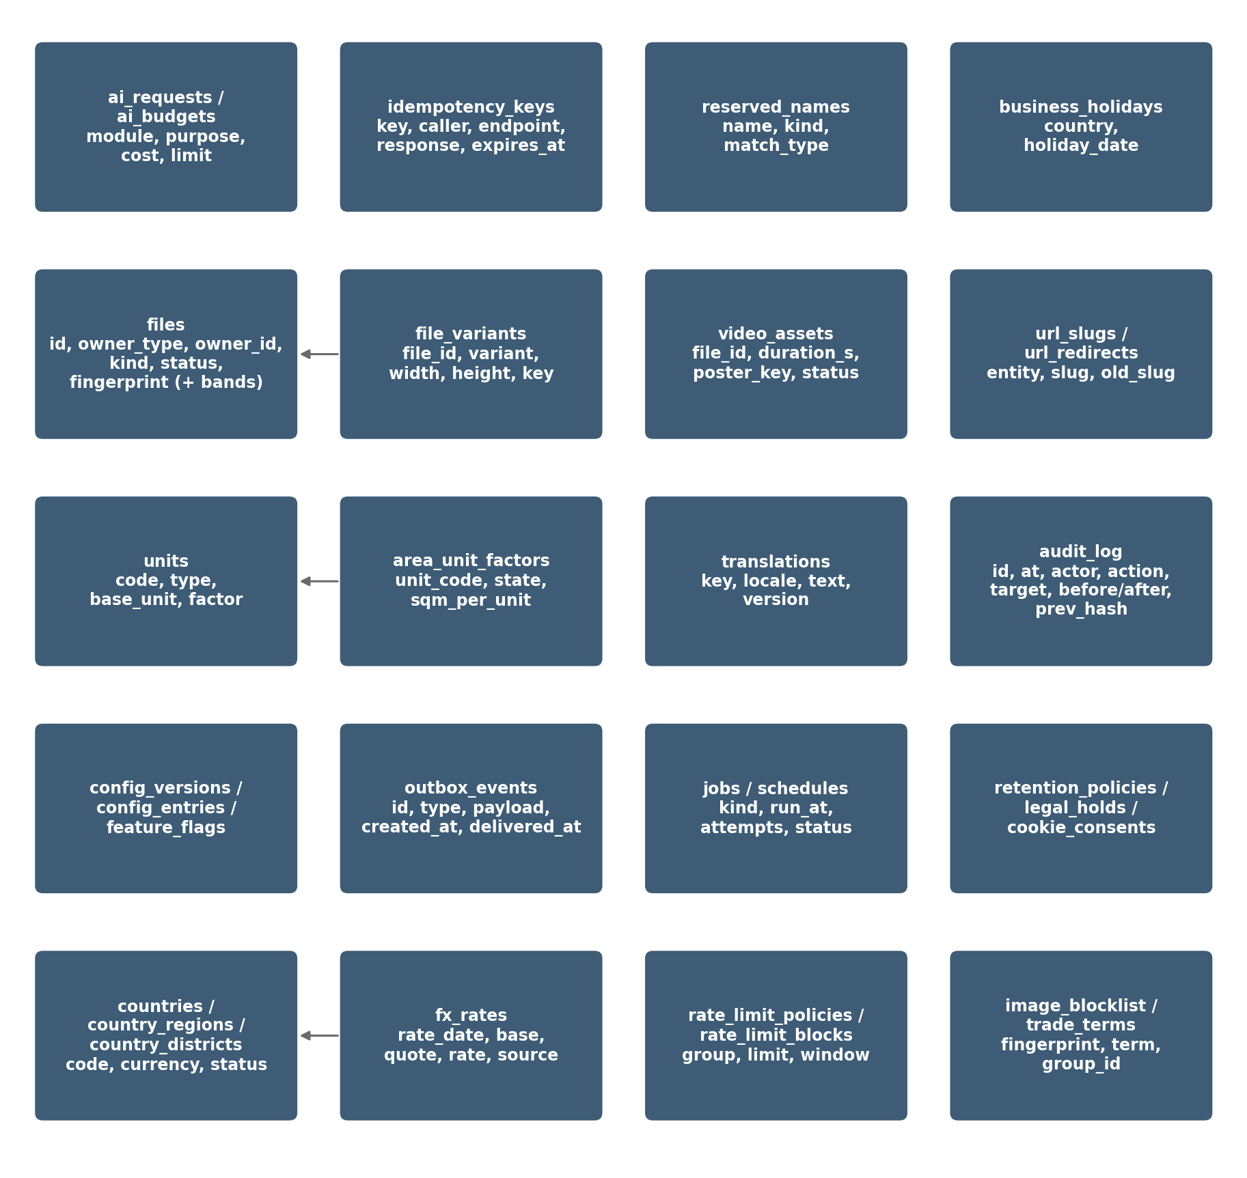
Figure 1 — Module 1 data model (overview)

1.2 How to read the table diagrams
The marks used in the table diagrams (PK, FK, ref, one / many, optional / required, dashed lines) are explained in the diagram key of the Master Database Design, Section 1.3. Diagrams show the main columns; the full column list is in each table below.

2. Files and Media
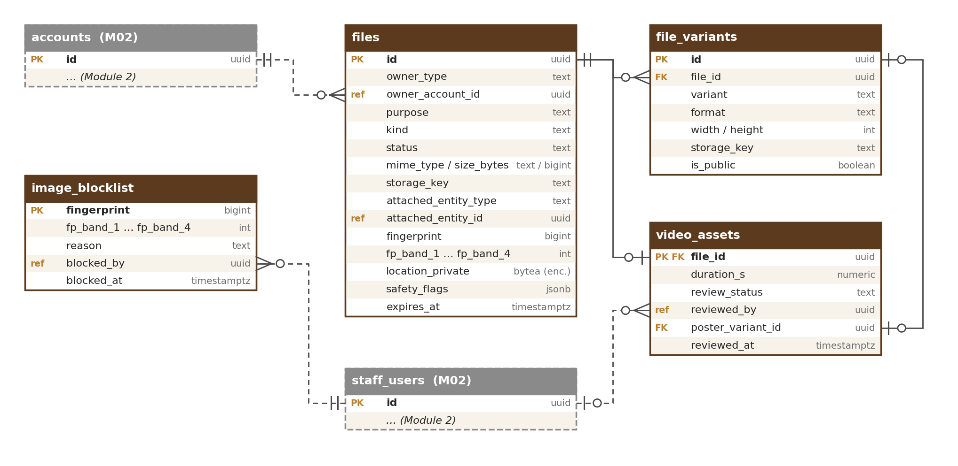
Figure 2 — Files and media tables

2.1 files
One row per uploaded file.
Column | Type | Notes
id | uuid PK
owner_type | text | account or staff (check)
owner_account_id | uuid | Uploading account, or staff user when owner_type = staff
purpose | text | listing_photo, listing_video, location_photo, location_video (business location media, M03), verification_doc, origin_doc, chat_attachment, avatar, cms_image…
kind | text | photo, document, video
original_name | text | Stored for display only
mime_type / size_bytes | text / bigint | Checked by file signature
status | text | pending_upload, uploaded, scanning, processing, held, in_review, ready, attached, expired, rejected_infected, rejected, failed, deleted (meaning of each state: M01-3 Section 2.1)
scan_result / scanned_at | text / timestamptz | clean / infected / error
storage_key | text | Private original object key
attached_entity_type / _id | text / uuid | Set when attached (e.g. listing). Shared link — see Section 11.1
quality_warning | text | small, blurred or null
has_watermark | boolean | Seller choice
location_private | bytea (encrypted) | GPS from the original photo, encrypted by the application; visible only to staff with the verification permission (M03); views audited
safety_flags | jsonb | Found text types: phone, email, upi, url, qr
fingerprint | bigint | Perceptual photo fingerprint (64-bit pHash)
fp_band_1 … fp_band_4 | int | The fingerprint cut into four 16-bit bands (values 0–65,535); each band indexed for similarity search (Section 14.1)
reject_reason | text | For rejected or failed
expires_at | timestamptz | Unconfirmed slot: 24 hours; unattached upload: 7 days

2.2 file_variants
Processed versions of a photo or video.
Column | Type | Notes
id | uuid PK
file_id | uuid FK → files
variant | text | thumb, medium, large, web_720p, poster
format | text | jpg, webp, mp4
width / height | int
storage_key / is_public | text / boolean | Public bucket only for approved photo and video variants

2.3 video_assets
Extra data for videos.
Column | Type | Notes
file_id | uuid PK, FK → files
duration_s | numeric(5,1) | ≤ 60 (configurable)
review_status | text | in_review, approved, rejected
reviewed_by / reviewed_at | uuid / timestamptz | Moderator (Module 12)
poster_variant_id | uuid FK → file_variants | Cover image

2.4 image_blocklist
Photos removed by moderation that may not be uploaded again.
Column | Type | Notes
fingerprint | bigint PK
fp_band_1 … fp_band_4 | int | Same four bands as files, each indexed, so near copies are also found
reason | text | copied, stock, banned
blocked_by / blocked_at | uuid / timestamptz | Moderator (Module 12)

3. Units
Units are shown together with countries in the diagram in Section 5 (bigha, katha and lessa factors depend on the state). Both unit tables are managed in the units screen (M01-6 Section 12.13) or moved from staging by export / import, with the same approval.

3.1 units
Standard and local units (Admin-managed).
Column | Type | Notes
code | text PK | g, kg, quintal, tonne, tola_w, mithqal, seer, maund, ml, l, tola_oil, qtola_oil, piece, stick, packet, box, bottle, plant, tree, acre, hectare, sqm, bigha, katha, lessa
type | text | weight, volume, count, area
base_unit | text | g, ml, none, sqm
factor_to_base | numeric(18,6) | e.g. tola_w 11.66, mithqal 4.25, tola_oil 12; null for count and state-based area
is_state_based | boolean | true for bigha, katha, lessa
label_key | text | Translation key
active / version | boolean / int | Retire, never delete

3.2 area_unit_factors
Factor per state for bigha, katha and lessa (state land-unit table, M01-2 UNT-009).
Column | Type | Notes
unit_code | text FK → units | bigha, katha, lessa
region_code | text FK → country_regions | ISO 3166-2, e.g. IN-AS (Assam)
sqm_per_unit | numeric(14,4) | Starting values for Assam and West Bengal in M01-2 UNT-009, e.g. IN-AS bigha 1,337.8038
source | text | State land record checked before the row was added (name and date); required
active | boolean | Retire, never delete
PK | (unit_code, region_code)

4. Languages and Preferences
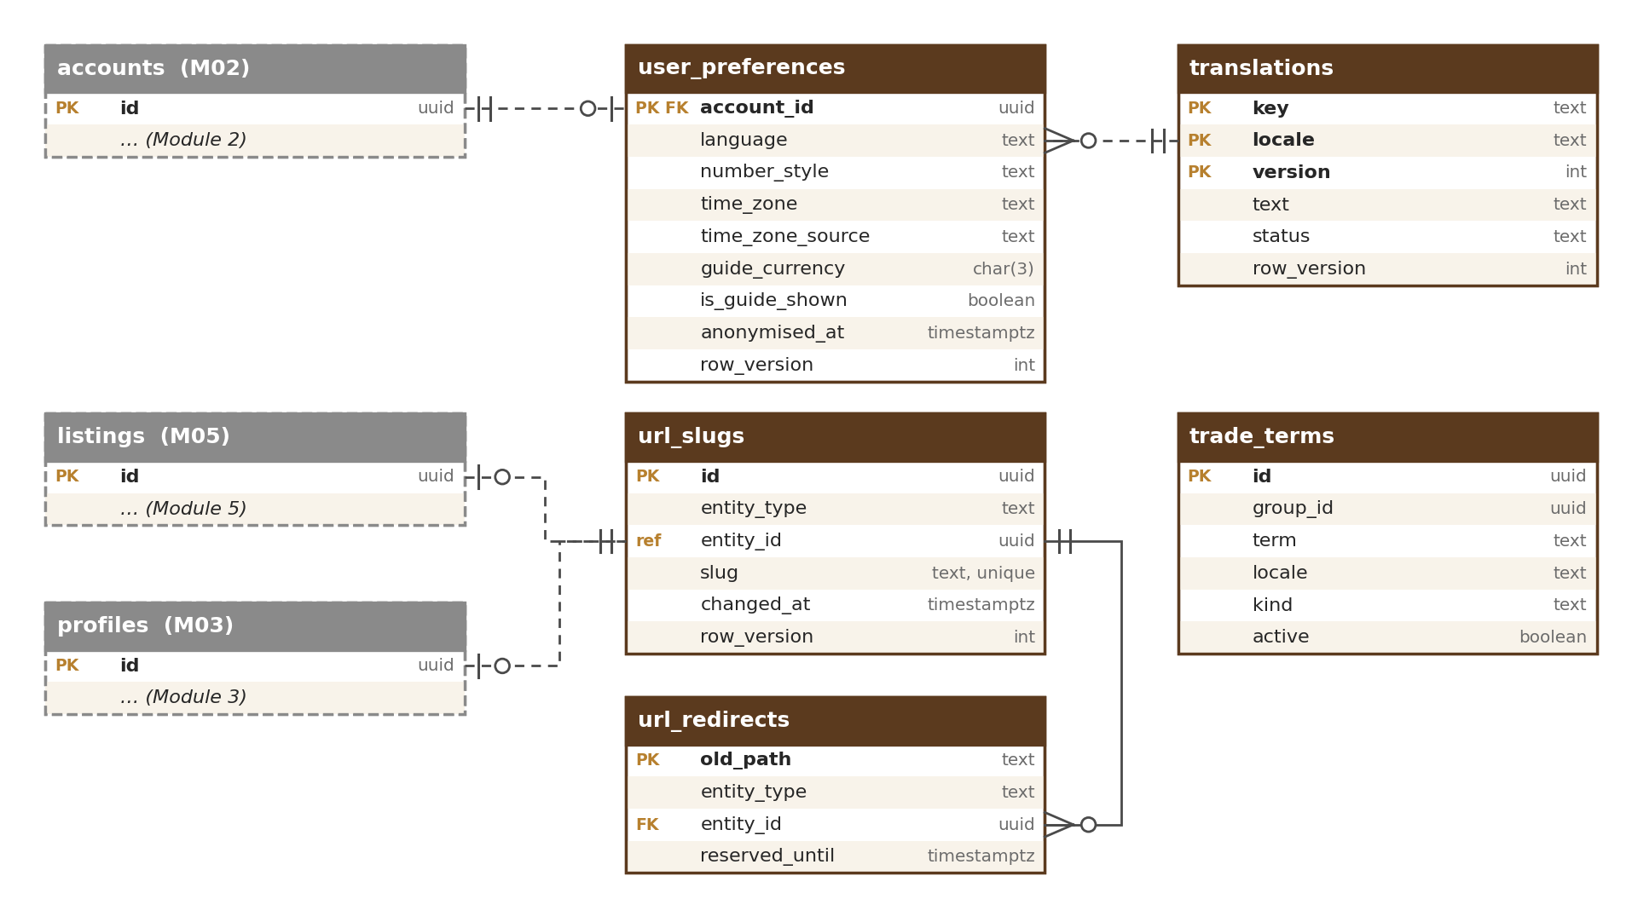
Figure 3 — Languages, preferences and page-address tables

4.1 translations
All user-facing text.
Column | Type | Notes
key | text | e.g. upload.error.too_large
locale | text | en, ar, hi…
text | text | May contain placeholders {name}
version / status | int / text | draft, published
PK | (key, locale, version)

4.2 user_preferences
Display preferences per account.
Column | Type | Notes
account_id | uuid PK
language | text | default en
number_style | text | indian or international
time_zone | text | IANA name, e.g. Asia/Kolkata
time_zone_source | text | How the time zone was set: country, browser or user. Written by M02; a zone chosen by the user is never overwritten by an automatic one
guide_currency / is_guide_shown | char(3) / boolean | Default from the Country table; viewer can change or switch off

4.3 trade_terms
Shared word list for names across languages and markets (filled by M04, used by M07).
Column | Type | Notes
id | uuid PK
group_id | uuid | Terms with the same meaning share a group (e.g. agarwood · oud · agar · gaharu · jinko · chen xiang)
term / locale | text / text | Term and its language
kind | text | product, grade, unit, origin
active | boolean | Retire, never delete

5. Countries and Exchange Rates
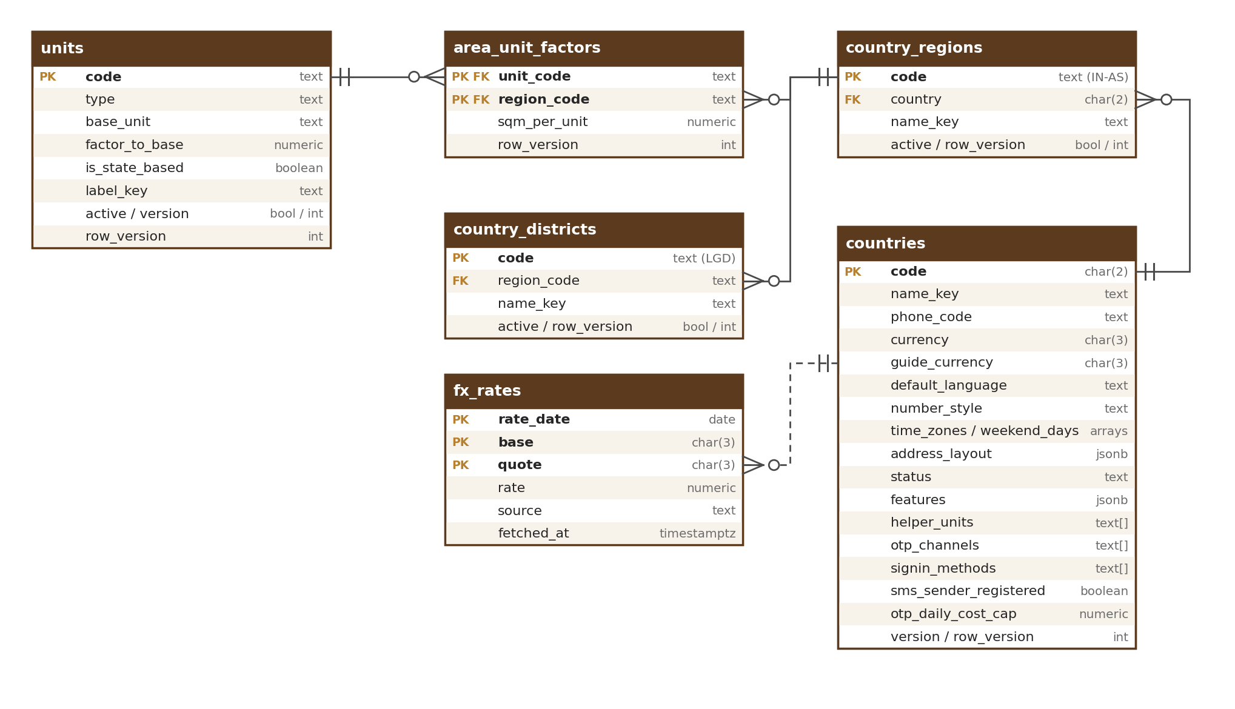
Figure 4 — Units, countries and exchange-rate tables

5.1 countries
Country table used by all modules (Admin-managed in the Country table screen, M01-6 Section 12.4).
Column | Type | Notes
code | char(2) PK | ISO 3166-1, e.g. IN, AE, SA, SG
name_key | text | Translation key
phone_code | text | e.g. +91, +971
currency / guide_currency | char(3) / char(3) | Listing currency (INR for IN, USD for others); guide currency e.g. AED
default_language / number_style | text / text | e.g. ar / international
time_zones / weekend_days | text[] / int[] | e.g. {Asia/Dubai} / {6,7}
address_layout | jsonb | Fields and order
status | text | allowed, restricted, blocked
features | jsonb | e.g. {“opportunities”: false}
helper_units | text[] | e.g. {tola_w, tola_oil, mithqal}
otp_channels | text[] | OTP channel order, read by M02 (CTY-008); values sms, whatsapp, email, voice; e.g. {sms,voice,whatsapp,email} for IN (voice-call codes on request), {sms,email} for CN, {whatsapp,sms,email} for most others
signin_methods | text[] | Allowed sign-in methods: password, google, apple, passkey; e.g. CN without google
sms_sender_registered | boolean | OudhTrade SMS sender name registered in this country (e.g. Saudi Arabia and UAE before R2); if false, codes go by WhatsApp or email
otp_daily_cost_cap / otp_cost_currency | numeric(16,2) / char(3) | Daily OTP sending cost limit for the country (protects against SMS pumping); starting values in M01-2 CTY-008 (IN 3,000 INR; others 50 USD); alert at 80 %
version | int | Published config version

5.2 country_regions
States and regions.
Column | Type | Notes
code | text PK | Full ISO 3166-2 code, e.g. IN-AS, IN-TR, AE-DU
country | char(2) FK → countries
name_key / active | text / boolean

5.3 country_districts
Districts (India at launch; other countries later if needed). Used by addresses, listings, profiles and lots.
Column | Type | Notes
code | text PK | India LGD district code (Local Government Directory)
region_code | text FK → country_regions | e.g. IN-AS
name_key / active | text / boolean | Retire, never delete (districts are split or renamed over time)

5.4 fx_rates
Daily exchange rates for guide prices.
Column | Type | Notes
rate_date / base / quote | date / char(3) / char(3) | PK; base INR or USD
rate | numeric(18,8)
source / fetched_at | text / timestamptz | Provider and time

6. Addresses
Page-address tables are shown in the diagram in Section 4. Reserved and banned names for store names and page addresses are in `reserved_names` (Section 13.4).

6.1 url_slugs
Current address of listings, stores, categories, guides.
Column | Type | Notes
id | uuid PK
entity_type / entity_id | text / uuid | Shared link (Section 11.1); UNIQUE (entity_type, entity_id) — one current address per record
slug | text | UNIQUE (entity_type, slug); e.g. assam-agarwood-chips-grade-a-10234; store: mrida-agro
changed_at | timestamptz | Store rename once per 90 days (M03 rule)

6.2 url_redirects
Old addresses that redirect permanently.
Column | Type | Notes
old_path | text PK | Natural key (Section 1.1); internal path only — check: starts with a single “/”, no scheme or host
entity_type / entity_id | text / uuid
reserved_until | timestamptz | Old store names cannot be claimed by others for 12 months

7. Audit Log
The audit log is shown with events, jobs, retention and consent in the diagram in Section 9.

7.1 audit_log
Append-only; INSERT and SELECT only for the application.
Column | Type | Notes
id | bigint identity | PK (id, occurred_at) — partitioned tables include the partition key in the primary key
occurred_at | timestamptz | Partition key (month)
actor_type / actor_id / actor_role | text / uuid / text | user, staff, agent, system, ai
action | text | e.g. listing.approve, account.ban, config.publish, document.view, file.location_view (with the reason), legal_hold.release, job.discard
target_type / target_id | text / uuid
reason | text
before / after | jsonb | Masked personal data
ip / user_agent | inet / text
request_id | text
hash / prev_hash | bytea | Tamper-evident chain; empty when written, filled in id order by the sealing job (M01-3 Section 6)

Indexes: (target_type, target_id, occurred_at), (actor_id, occurred_at), (action, occurred_at), and a partial index on unsealed records (hash is null). Partitioned by month; each month is one hash chain, sealed when the month closes. Nightly copy to S3 with Object Lock (7 years).

8. Configuration, Switches and Rate Limits
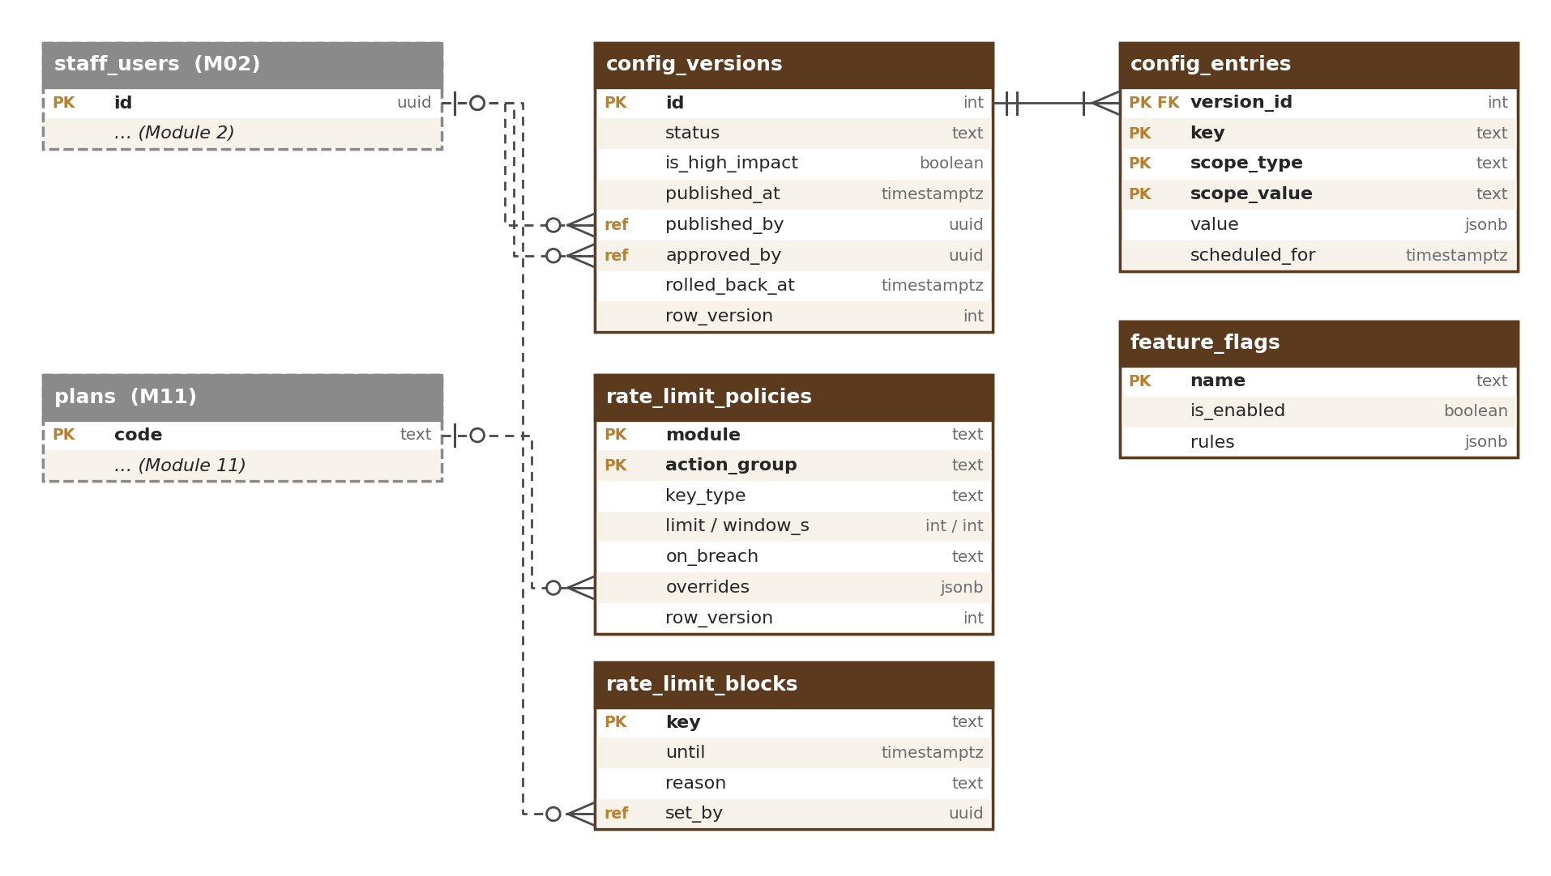
Figure 5 — Settings, feature-switch and rate-limit tables

8.1 config_versions / config_entries
Versioned settings, prepared and approved in the Configuration Console (M16) with the common settings pattern (M01-6 Section 12.1) and published only through ConfigService.publish (M01-2 CFG-006).
Column | Type | Notes
config_versions.id / status | int / text | draft → approved → published; a published version can later be rolled_back (check on allowed moves)
config_versions.is_high_impact | boolean | True when the version changes any high-impact setting in the list of M01-6 Section 12.1 (e.g. trust and ranking weights, prices, limits, permissions, compliance rules, legal texts, production feature switches, rate limits, AI budgets, Country table features); set by ConfigService from the setting’s tag, never by the editor
config_versions.approved_by / approved_at | uuid / timestamptz | approved_by must differ from created_by for every version (check constraint): a second person always approves. When is_high_impact is true the approver must be a Super Admin (checked by ConfigService, M01-6 Section 12.1)
config_versions.published_at / published_by | timestamptz / uuid | Set by ConfigService.publish; emits config.published
config_versions.rolled_back_at / rolled_back_by / rollback_reason | timestamptz / uuid / text | Rollback publishes an earlier version again as a new version; both audited
config_entries.version_id / key / value | int / text / jsonb | e.g. files.photo.max_mb = 15
config_entries.scheduled_for | timestamptz | Scheduled changes
config_entries.scope_type / scope_value | text / text | global, country, category, plan, role, account_list; most specific wins: account list → role → plan → category → country → global (CFG-005)

8.2 feature_flags
Release switches.
Column | Type | Notes
name | text PK | e.g. r2.messaging
is_enabled / rules | boolean / jsonb | Targets: release, environment, role, account list

8.3 rate_limit_policies
Limits registered by each module (counters live in Redis).
Column | Type | Notes
module / action_group | text / text | PK, e.g. M01 / photo_upload
key_type | text | ip, device, account, plan, api_key
limit / window_s | int / int | e.g. 100 / 3600
on_breach | text | wait, challenge, block_15m, security_event
overrides | jsonb | By plan, role, country

8.4 rate_limit_blocks
Temporary and staff-set blocks.
Column | Type | Notes
key | text PK | e.g. ip:203.0.113.5
until / reason | timestamptz / text | Null until = permanent (staff only)
set_by | uuid | System or staff user

9. Events and Jobs
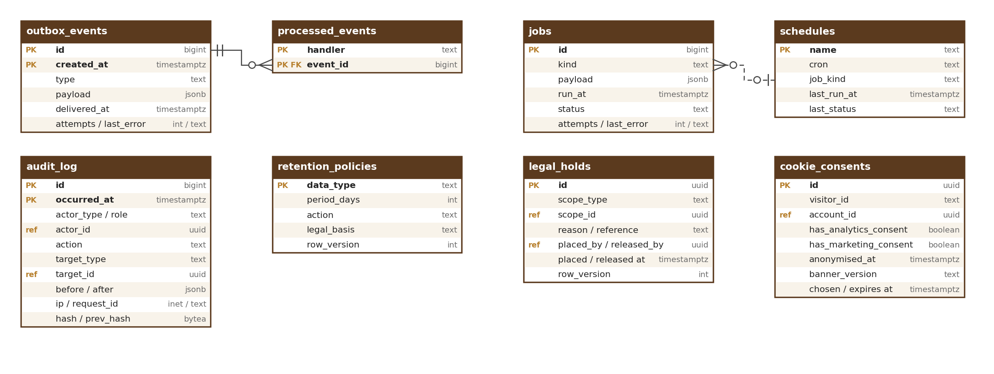
Figure 6 — Events, jobs, audit log, retention and consent tables

9.1 outbox_events
Events written with the business change.
Column | Type | Notes
id | bigint identity | PK (id, created_at)
type / payload | text / jsonb | e.g. file.ready; names from the event catalogue (HLD Appendix B)
created_at / delivered_at | timestamptz | delivered_at null until relayed
attempts / last_error | int / text

outbox_events is partitioned by month on created_at; delivered months are dropped after 30 days (configurable). processed_events rows older than 30 days are deleted by the same clean-up.

9.2 processed_events
Idempotency per handler.
Column | Type | Notes
handler / event_id | text / bigint | PK (handler, event_id)

9.3 jobs / schedules
Background work.
Column | Type | Notes
jobs.id / kind / payload | bigint / text / jsonb
jobs.run_at / status / attempts / last_error | timestamptz / text / int / text | queued, running, done, dead (dead-letter), discarded (by staff with a reason, audited; failed jobs screen, M01-6 Section 12.11)
schedules.name / cron / job_kind / last_run_at / last_status | text / text / text / timestamptz / text | e.g. retention.run 02:00 IST creates a retention job

10. Retention, Legal Hold and Consent

10.1 retention_policies
Retention per data type. Managed in the retention policies screen (M01-6 Section 12.12) or moved from staging by export / import; changes are high impact.
Column | Type | Notes
data_type | text PK | e.g. unattached_upload, closed_account, security_log
period_days | int | [TBC: final with counsel]
legal_min_days | int | Shortest period the law allows; period_days can never be lower (check)
action | text | delete or anonymise
legal_basis | text | Why kept this long

10.2 legal_holds
Stops deletion for linked data. Placed and released in the legal hold screen (M01-6 Section 12.10) or automatically by takedowns (M12).
Column | Type | Notes
id | uuid PK
scope_type / scope_id | text / uuid | account, listing, thread…
reason / reference | text | Legal order or dispute reference
placed_by / placed_at / released_by / released_at | uuid / timestamptz | All audited; placed_by null = system (takedown)
release_reason | text | Required when released_at is set (check)

10.3 cookie_consents
Proof of cookie choices.
Column | Type | Notes
id | uuid PK
visitor_id / account_id | text / uuid | Account if signed in
has_analytics_consent / has_marketing_consent | boolean
banner_version / chosen_at / expires_at | text / timestamptz | 12 months

11. Links to Other Modules
Module 1 tables hold only the IDs of records that belong to other modules. There are no database foreign keys across modules, so each module can change (or later be split out) without breaking Module 1. The owning module keeps the link correct through its interface and events — for example, when an account is closed (Module 2), Module 1 anonymises that account’s preferences and consents.
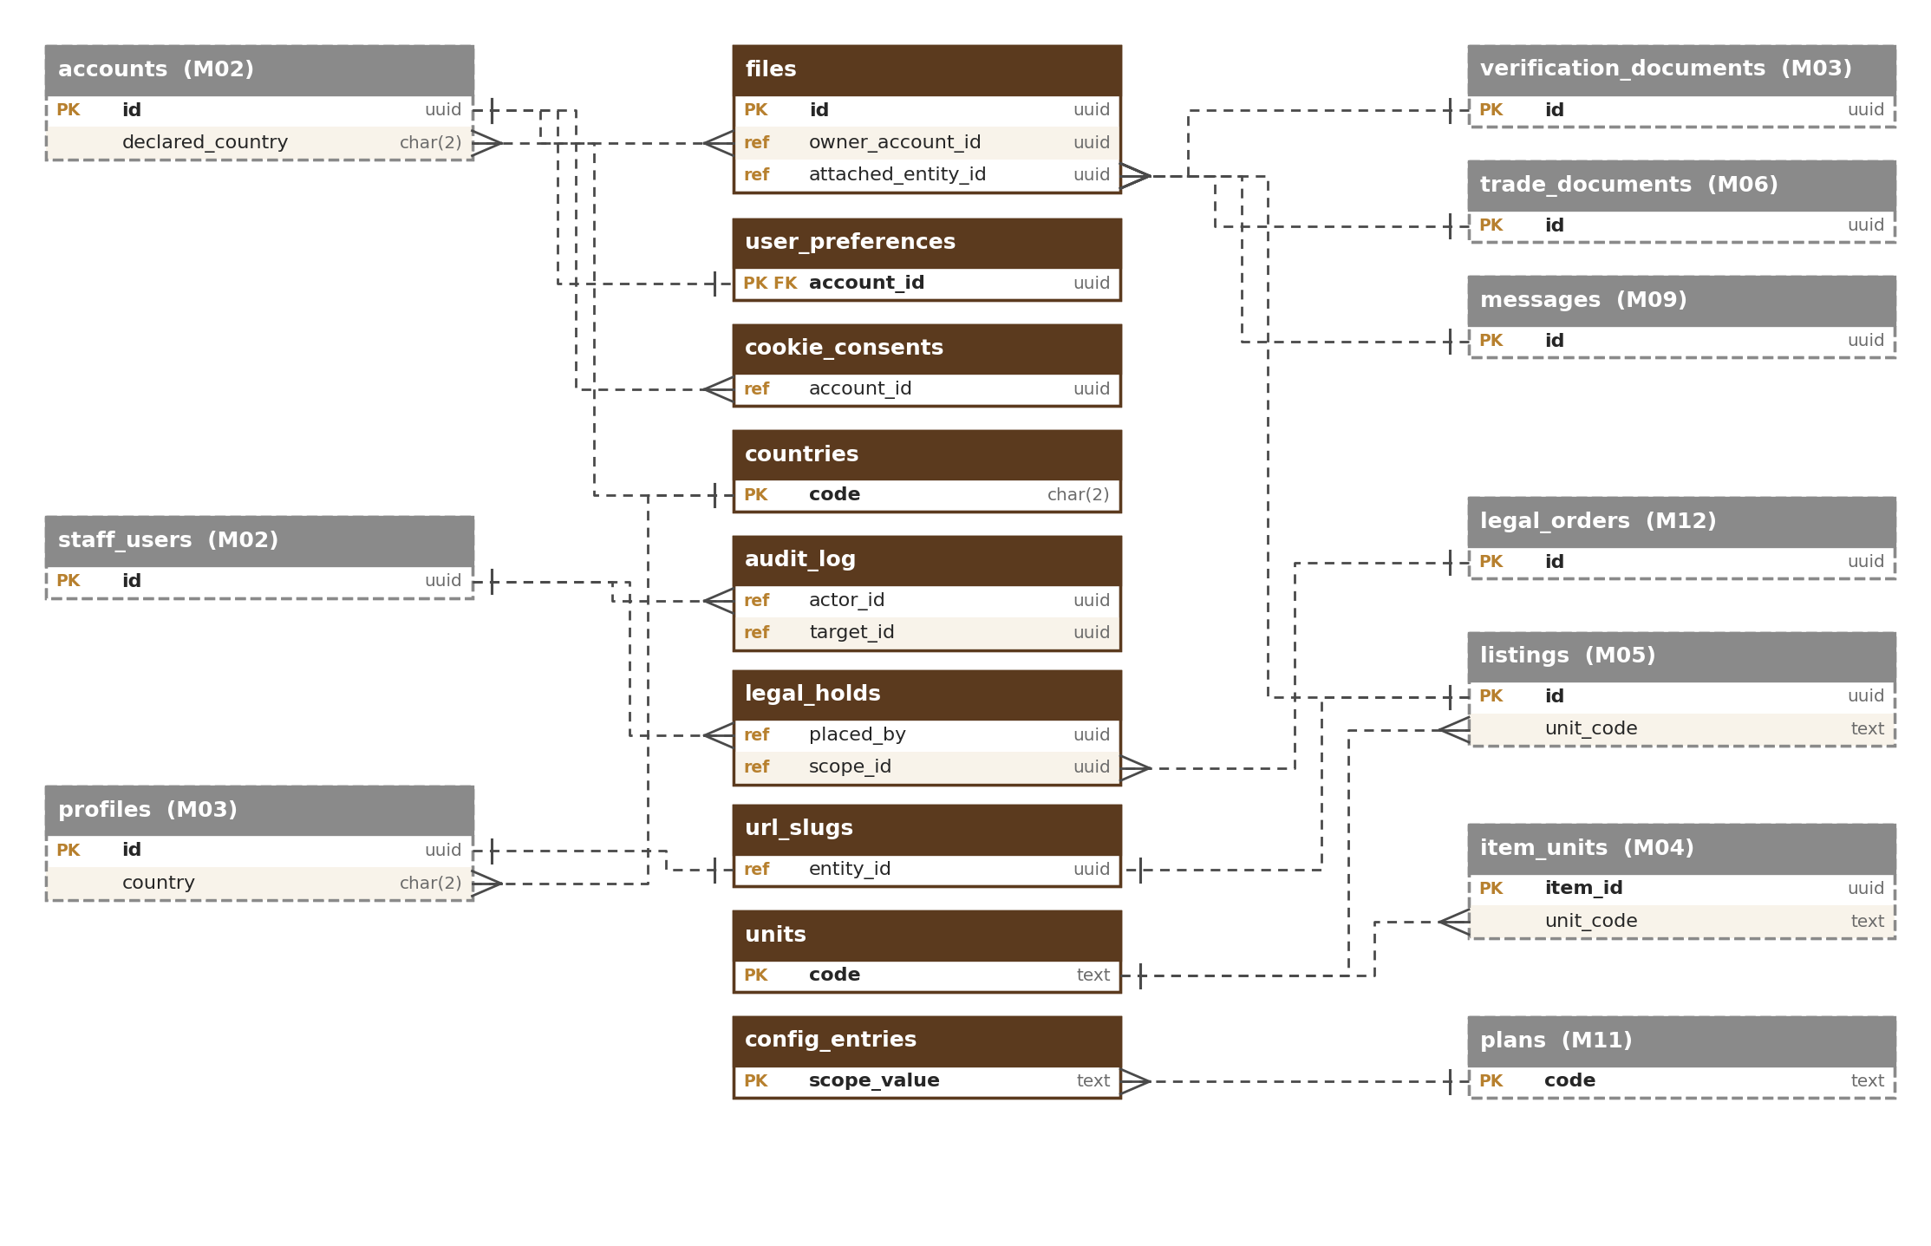
Figure 7 — Links from Module 1 tables to other modules
Module 1 column | Points to | Owner
files.owner_account_id (owner_type = account), user_preferences.account_id, cookie_consents.account_id, ai_requests.account_id, idempotency_keys.caller_id | accounts | M02
files.owner_account_id (owner_type = staff), audit_log.actor_id, legal_holds.placed_by, config_versions.published_by / approved_by, video_assets.reviewed_by, image_blocklist.blocked_by, rate_limit_blocks.set_by | staff_users (or accounts for user actions) | M02
files.attached_entity_id | verification_documents, trade_documents, listings, messages, profiles, pages (by attached_entity_type) | M03, M06, M05, M09, M03, M17
url_slugs.entity_id | listings, profiles (stores), taxonomy_nodes (categories), pages (guides) | M05, M03, M04, M17
legal_holds.scope_id | legal_orders and the held records (by scope_type) | M12, M02, M05, M09
audit_log.target_id | Any record acted on (by target_type) | All modules
units.code (used by) | item_units.unit_code, listings.unit_code | M04, M05
countries.code (used by) | accounts.declared_country, accounts.phone_country, accounts.signup_ip_country, profiles.country | M02, M03
country_regions.code / country_districts.code (used by) | region_code and district_code of profiles, listings, lots | M03, M05, M06
config_entries.scope_value (plan) | plans.code | M11

Table names of other modules are planned names; they are confirmed in each module’s database design. Links of the Section 13 tables are shown in the diagram in Section 13.

11.1 Shared link columns
Four Module 1 tables use a shared link (a “type” column plus an “ID” column): `files.attached_entity_type / attached_entity_id`, `url_slugs.entity_type / entity_id`, `audit_log.target_type / target_id` and `legal_holds.scope_type / scope_id`. They follow the shared-link rules of the Master Database Design (Section 6.1). Module 1 specifics:
- Allowed types (named after the target table, database check): files — listing, verification_document, trade_document, message, profile, page; addresses — listing, profile, taxonomy_node, page; audit log targets — account, staff_user, profile, listing, requirement, thread, message, quotation, trade, review, verification_case, moderation_case, legal_order, subscription, invoice, file, config_version, legal_hold (new types added with the owning module’s design); legal holds — account, profile, listing, thread, trade, legal_order.
- Index: each (type, ID) pair is indexed: files (attached_entity_type, attached_entity_id), url_slugs (entity_type, entity_id) unique, audit_log (target_type, target_id, occurred_at), legal_holds (scope_type, scope_id).
- Clean-up: on `listing.removed`, `document.deleted`, `message.deleted` and `account.closed` Module 1 detaches files and redirects or retires the address. Audit targets are never removed (the audit log keeps the ID even after the record is gone); a legal hold whose record is gone stays until staff release it.
- Nightly check: schedule `refs.orphan_check` (M01-3) reports links of all four tables that point to missing records; for the audit log it only reports, never changes records.

12. Rules
Module 1 follows the standards of the Master Database Design (naming, IDs and UUID version 7, standard columns, data types, schema as code, safe migrations, database users). Module 1 specifics:
- The audit log, outbox, jobs and ai_requests use bigint identity keys; audit_log, outbox_events and ai_requests are partitioned by month and include the time column in the primary key.
- Reference data (units, translations, countries, config versions, reserved names, holidays) is retired (active = false), never deleted.
- Foreign keys are enforced by the database inside Module 1; links to other modules are ID references (ref) without database constraints.
- Personal-data columns (files.location_private, user_preferences, cookie_consents, audit_log actor and IP, rate_limit_blocks key, ai_requests.account_id, idempotency_keys stored responses) are listed in the master data map and covered by retention policies.

13. AI Gateway, API Safety, Names and Calendar
Five tables support the AI gateway (M01-3 Section 14), idempotency keys (API-005), reserved names (URL-008) and the holiday calendar (LOC-012). Standard columns (Section 1.1) apply as usual.
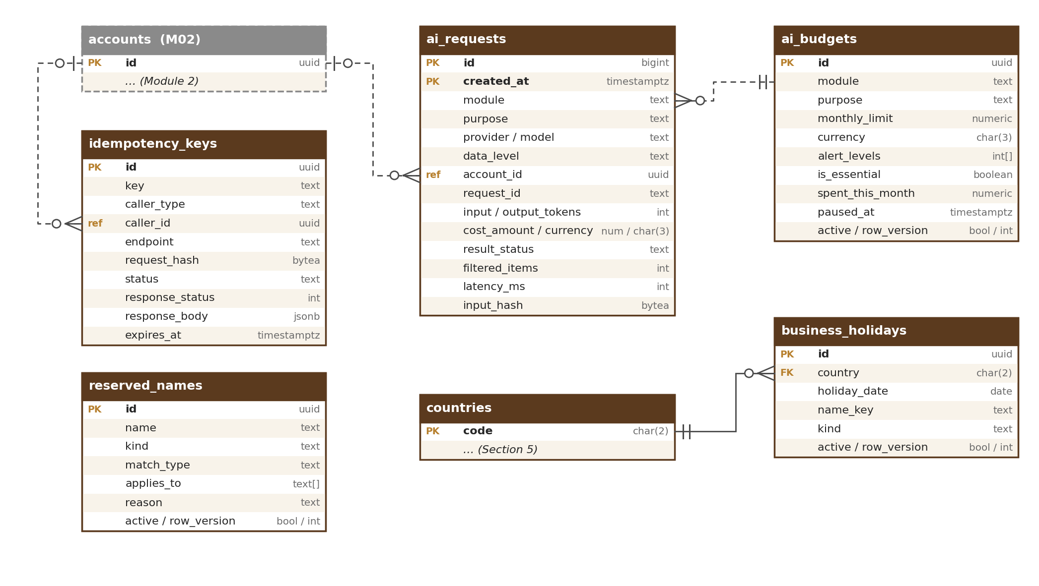
Figure 8 — AI gateway, API safety, names and calendar tables

13.1 ai_requests
One row per AI call through the gateway (AIG-003). Append-only; partitioned by month on created_at.
Column | Type | Notes
id | bigint identity | PK (id, created_at)
created_at | timestamptz | Time of the call; partition key
module / purpose | text / text | e.g. M07 / search_embedding
provider / model | text / text | Provider and model version used
data_level | text | public, internal, confidential (check); Restricted data is never sent
account_id | uuid (ref) | Account whose personal data was sent, if any (processing log); otherwise null
request_id | text | Links to the API request and logs
input_tokens / output_tokens | int / int
cost_amount / cost_currency | numeric(16,6) / char(3) | Six decimals because one call costs a fraction of a cent; totals are rounded to 2 decimals
result_status | text | ok, blocked_by_filter, over_budget, provider_error, timeout
filtered_items / latency_ms | int / int | Items removed by the data filter; response time
input_hash | bytea | SHA-256 of what was sent; prompt and output text are not stored

13.2 ai_budgets
Monthly AI cost limits per module and purpose, with alert levels (AIG-004).
Column | Type | Notes
id | uuid PK
module / purpose | text / text | UNIQUE (module, purpose); purpose “*” = all purposes of the module
monthly_limit / currency | numeric(16,2) / char(3) | Starting values in M01-2 AIG-004, e.g. 120.00 USD for moderation
alert_levels | int[] | Per cent; default {80, 100}
is_essential | boolean | Essential purposes keep running at 100 % (alert only); others pause
spent_this_month | numeric(16,2) | Reconciled hourly from ai_requests
paused_at | timestamptz | Set when a non-essential purpose pauses; cleared at month start or when the limit is raised
active | boolean

13.3 idempotency_keys
Makes retried writes safe (API-005): the first response is stored for 24 hours and returned for repeats.
Column | Type | Notes
id | uuid PK
key | text | Value of the Idempotency-Key header (a UUID made by the client)
caller_type / caller_id | text / uuid (ref) | account, staff_user or api_key; UNIQUE (caller_type, caller_id, endpoint, key)
endpoint | text | Method and path pattern, e.g. POST /v1/files
request_hash | bytea | SHA-256 of the request body; a different body with the same key is refused
status | text | in_progress, completed
response_status / response_body | int / jsonb | Stored first response
expires_at | timestamptz | created_at + 24 hours; expired rows deleted hourly

13.4 reserved_names
Reserved, banned and protected brand names for store names and page addresses (URL-008). Managed in the reserved-names screen (M01-6 Section 12.5) or moved from staging by export / import, with the same approval.
Column | Type | Notes
id | uuid PK
name | text | Normalised form (lower case, transliterated, look-alike characters folded)
kind | text | reserved (e.g. admin, help, oudhtrade), banned, protected_brand; UNIQUE (name, kind)
match_type | text | exact or contains
applies_to | text[] | store_name, page_address
reason | text | e.g. brand owner, legal order reference
active | boolean | Retire, never delete

13.5 business_holidays
Holiday calendar used by the IST business-hours calculator (LOC-012). Managed in the holiday calendar screen (M01-6 Section 12.6) or moved from staging by export / import, with the same approval.
Column | Type | Notes
id | uuid PK
country | char(2) FK → countries | IN at launch
holiday_date | date | UNIQUE (country, holiday_date)
name_key | text | Translation key, e.g. holiday.diwali
kind | text | national or company
active | boolean | Retire, never delete

14. Indexes and Volumes
Main indexes and a year-1 row estimate for every Module 1 table. Every link column is indexed (Master Database Design, Section 9.3). Figures are estimates for design; load tests before R2 confirm them.
Table | Main indexes (besides the primary key) | Rows, year 1
files | (owner_type, owner_account_id, status); (attached_entity_type, attached_entity_id); (status, expires_at); fp_band_1, fp_band_2, fp_band_3, fp_band_4 (each, photos only) | ≈ 1.2 million
file_variants | (file_id) | ≈ 3.6 million
video_assets | (review_status) | ≈ 20,000
image_blocklist | fp_band_1 … fp_band_4 (each) | < 10,000
units · area_unit_factors | (type, active) · (region_code) | < 50 · < 200
translations | (locale, status) | ≈ 20,000
user_preferences | — | ≈ 50,000
trade_terms | (group_id); (lower(term), locale) | < 5,000
countries · country_regions · country_districts | (status) · (country) · (region_code) | ≈ 250 · ≈ 5,000 · ≈ 800
fx_rates | (quote, rate_date) | ≈ 4,000
url_slugs | UNIQUE (entity_type, entity_id); UNIQUE (entity_type, slug) | ≈ 170,000
url_redirects | (entity_type, entity_id); (reserved_until) | ≈ 50,000
audit_log | (target_type, target_id, occurred_at); (actor_id, occurred_at); (action, occurred_at); partial (hash is null) | ≈ 5 million (kept 7 years)
config_versions · config_entries | (status) · (key, scope_type, scope_value) | < 1,000 · ≈ 50,000
feature_flags · rate_limit_policies | — | < 200 each
rate_limit_blocks | (until) | < 50,000 (short-lived)
outbox_events | partial (delivered_at is null, created_at) | ≈ 10 million a year (dropped after 30 days)
processed_events | — | Cleaned after 30 days
jobs · schedules | (status, run_at) · — | ≈ 5 million (done jobs cleaned after 30 days) · < 100
retention_policies · legal_holds | — · (scope_type, scope_id); (released_at) | < 100 · < 500
cookie_consents | (visitor_id); (account_id) | ≈ 500,000
ai_requests | (module, purpose, created_at); (account_id) | ≈ 1–3 million (depends on the AI features switched on)
ai_budgets | UNIQUE (module, purpose) | < 100
idempotency_keys | UNIQUE (caller_type, caller_id, endpoint, key); (expires_at) | ≈ 50,000 live (24 hours)
reserved_names | UNIQUE (name, kind); (kind, active) | ≈ 5,000
business_holidays | UNIQUE (country, holiday_date) | ≈ 20 a year

14.1 Photo fingerprint search
- Each photo stores its 64-bit fingerprint and the same value cut into four 16-bit bands (fp_band_1 … fp_band_4), each with its own index.
- To find copies, the database first looks for candidates that share at least one band with the new photo (four fast index look-ups), then checks each candidate by Hamming distance (number of differing bits) against the configurable threshold.
- Two fingerprints that differ in 3 bits or fewer always share at least one band, so no match within that distance is missed (starting threshold, tuned on real photos). The block list (image_blocklist) is searched the same way.

